**Batch: \_\_B1\_\_\_ Roll No.:\_\_1611077\_\_ Exp NO:\_2\_**

**Title:** To represent standard discrete time signals & perform different operations on them.

**Objective:** To familiarize the beginner to MATLAB by introducing the basic featuresand commands of the program.

**Expected Outcome of Experiment:**

|  |  |
| --- | --- |
| **CO** | **Outcome** |
|  |  |
| **CO1** | Identify various discrete time signals and systems and perform signal |
| manipulation |
|  |
|  |  |

**Books/ Journals/ Websites referred:**

1. http://www.mathworks.com/support/
2. www.math.mtu.edu/~msgocken/intro/intro.html
3. www.mccormick.northwestern.edu/docs/efirst/matlab.pdf
4. A.Nagoor Kani “Digital Signal Processing”, 2nd Edition, TMH Education.

**Pre Lab/ Prior Concepts:**

1. Unit Impulse Signal

The impulse signal is defined as

**d[n] = k ; if n=0**

**= 0 ; otherwise**

When k=1 it is called as unit impulse

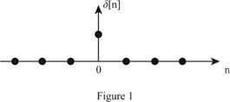

1. Unit Step Signal

The step signal is defined as

**U[n] = k ; if n>=0**

**= 0 ; otherwise**

When k=1 it is called as unit step signal.

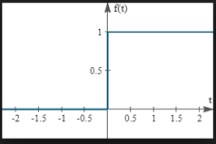

1. Ramp Signal

The ramp signal is defined as:

**r[n] = n ; if n>=0**

**= 0 ; otherwise**

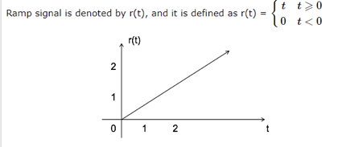

1. Exponential Signal

The exponential signal is defined as

**X[n] =a^n**

When ‘a’ is greater than 1 it is increasing exponential

When ‘a’ is less than 1 it is decaying exponential.

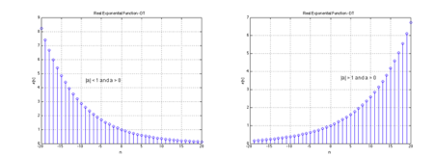

1. Discrete Time sinusoidal Signal

A discrete-time signal is periodic if there is a non-zero integer p ∈ DiscreteTime such that for all n ∈ DiscreteTime,

**x(n + p) = x(n).**

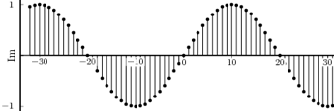

**Operations on Signals:**

1. Addition of signals.

Addition of two signals is nothing but addition of their corresponding amplitudes. This can be best explained by using the following example:

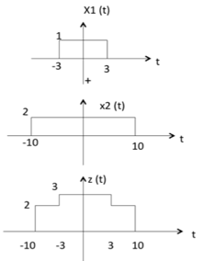

1. Multiplication of two signals.

Multiplication of two signals is nothing but multiplication of their corresponding amplitudes.

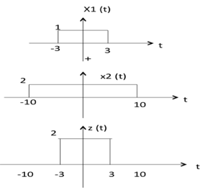

1. Scaling – Amplitude Scaling, Up-scaling & Down-scaling.

Multiplication of a constant with the amplitude of the signal causes amplitude scaling. Depending upon the sign of the constant, it may be either amplitude scaling or attenuation.

UP SCALING-

Here if we divide the signal with a certain magnitude, the total signal size increases or amplifies.

DOWN SCALING-

Here if we multiply the signal with a certain magnitude, the total signal size decreases or becomes small as compared to the initial signal.

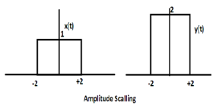

1. Shift operation – Advance/Right shift & Delay/Left shift.

* If a signal can be expressed in the form **x(t) = s(t - t1)**,

we say x(t) is a *time-shifted* version of s(t).

|  |
| --- |
| \scalebox{0.85}{\includegraphics{eps/time_shift.eps}} |

* Consider the simple function

s(t) = t 0 <=t<=1

* Shifting the function by t1 = 2 seconds yields

|  |  |  |  |
| --- | --- | --- | --- |
| x(t) = s(t-2) =  =  which is simply s(t) with its origin shifted to the right, or delayed, by 2 seconds. | t - 2  t - 2 | 0<=t-2<=1  2<=t<=3 |  |

* Shifting the function by t1 = 2 seconds yields

|  |  |  |  |
| --- | --- | --- | --- |
| x(t) = s(t+1) =  =  which is simply s(t) with its origin shifted to the left, or advanced in time, by 1 seconds. | t + 1  t + 1 | 0<=t+1<=1  -1<=t<=0 |  |

* A positive phase indicates a shift to left whereas a negative phase indicates a shift to the right.

**Steps with Syntax for representation of above operations on discrete time signals:**

x=-1:0.15:4;

impulse = x==0;

subplot(3,3,1)

stem(x,impulse)

title('IMPULSE')

xlabel('n')

ylabel('d(n)')

unitStep = x>=0;

subplot(3,3,2)

stem(x,unitStep)

title('UNIT STEP')

xlabel('n')

ylabel('u(n)')

ramp = x.\*(x>=0);

subplot(3,3,3)

stem(x,ramp)

xlabel('n')

ylabel('un(n)')

title('RAMP')

expo1 = 2.^x;

subplot(3,3,4)

stem(x,expo1)

title('EXPONENTIAL(a>=1)')

xlabel('n')

ylabel('g(n)')

expo2 = (0.2).^x;

subplot(3,3,5)

stem(x,expo2)

title('EXPONENTIAL(a<1)')

xlabel('n')

ylabel('g(n)')

sine = sin(x);

subplot(3,3,6)

stem(x, sine)

title('SINE WAVE')

xlabel('n')

ylabel('f(n)')

cosine = cos(x);

subplot(3,3,7)

stem(x, cosine)

title('COSINE WAVE')

xlabel('n')

ylabel('f(n)')

sine2 = sin(2\*x);

subplot(3,3,9)

stem(x, sine2)

title('SINE WAVE with phase doubled ')

xlabel('n')

ylabel('f(n)')

sine3 = 2\*sin(x);

subplot(3,3,8)

stem(x, sine3)

title('SINE WAVE with amplitude doubled')

xlabel('n')

ylabel('f(n)')

sine4 = sin(x)+cos(x)

subplot(4,3,10)

stem(x, sine4)

title('ADDITION')

xlabel('n')

ylabel('f(n)')

sine5 = sin(x)-cos(x)

subplot(4,3,11)

stem(x, sine5)

title('SUBTRACTION')

xlabel('n')

ylabel('f(n)')

sine6 = sin(x).\*cos(x)

subplot(4,3,12)

stem(x, sine6)

title('MULTIPLICATION')

xlabel('n')

ylabel('f(n)')

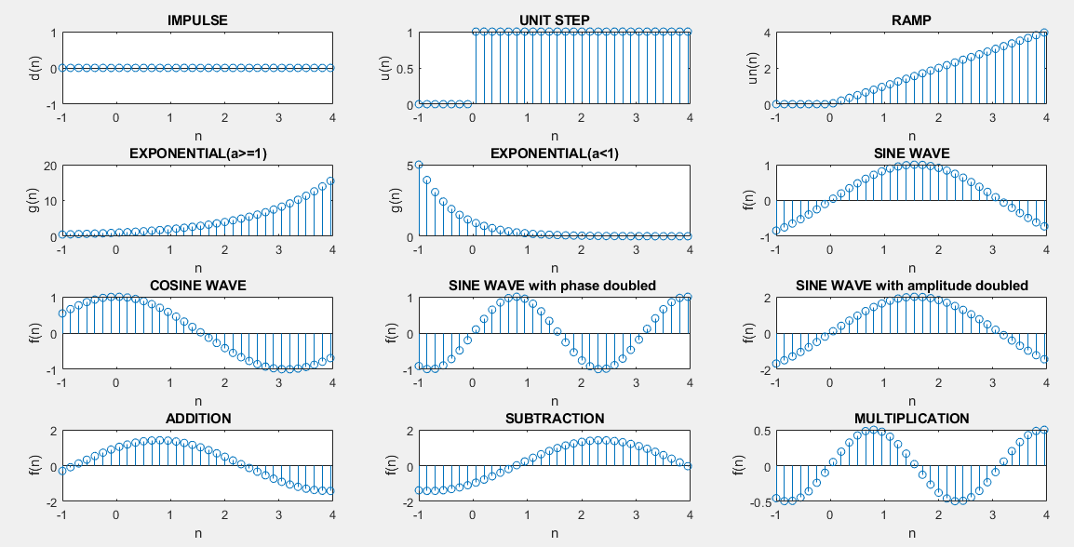

arr = [-2,-1,0,1,2,3,4,5];

n=0:7;

subplot(4,2,1)

stem(n,arr)

title('Actual')

shift = input('Enter the shift: ');

subplot(4,2,3)

stem(n-shift,arr)

title('Advance')

subplot(4,2,4)

stem(n+shift,arr)

title('Delay')

scale = input('Enter scaling factor: ');

subplot(4,2,5)

stem(n, arr.\*scale)

title('Upscale')

subplot(4,2,6)

stem(n, arr./scale)

title('Downscale')

subplot(4,2,7)

stem(n,-arr)

title('Mirror across X')

subplot(4,2,8)

stem(-n,arr)

title('Miiror across Y')

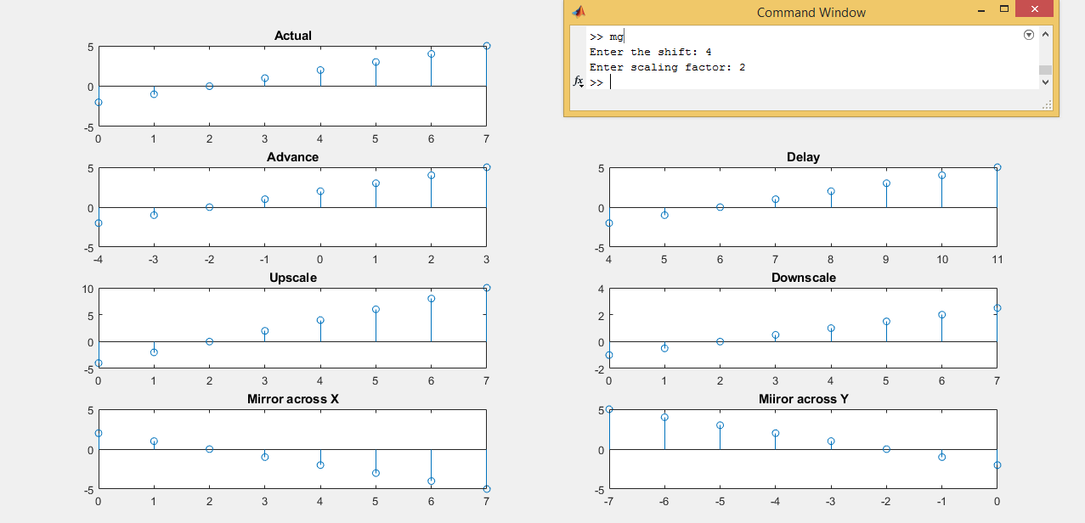

x=0:0.02:4;

sine = sin(x);

subplot(3,1,1)

stem(x, sine)

title('ACTUAL')

xlabel('n')

ylabel('f(n)')

x=0:0.01:4;

sine1 = sin(x);

subplot(3,1,2)

stem(x, sine1)

title('UP-SAMPLING')

xlabel('n')

ylabel('f(n)')

x=0:0.05:4;

sine2 = sin(x);

subplot(3,1,3)

stem(x, sine2)

title('DOWN-SAMPLING')

xlabel('n')

ylabel('f(n)')

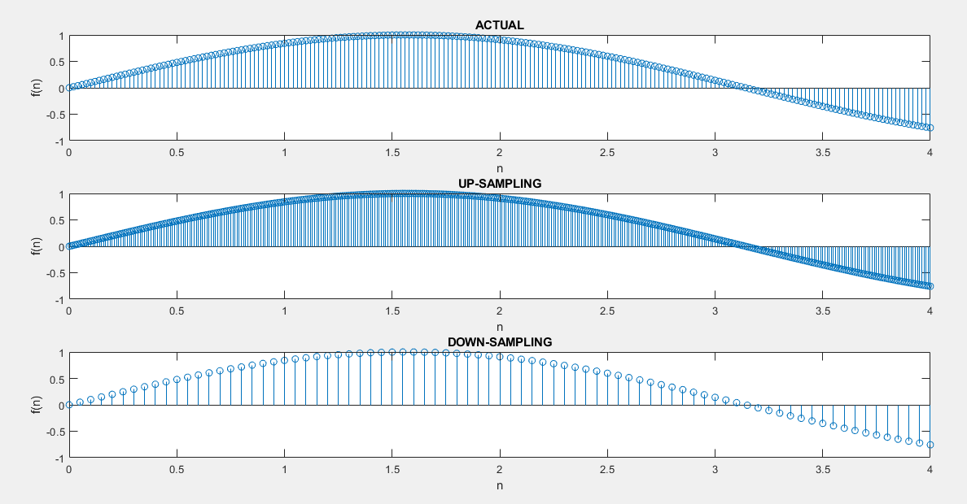

**Conclusion:-**

Thus, we have learnt to represent standard discrete time signals & perform different operations on them.

**Post Lab Questions**

1. **The process of conversion of continuous time signal into discrete time signal is known as \_\_\_SAMPLING\_\_\_\_**
2. **Which of the following is example of deterministic signal?**
   1. Step
   2. Ramp
   3. Exponential
   4. **All of the above**

**Ans. All of the above**

1. **For energy signals the energy will be finite and the average power will be \_\_0\_\_**
2. **In a signal x(n), if ‘n’ is replaced by ‘n/3’ the it is called \_\_UPSAMPLING\_\_.**
3. **The system y(n)=sin[x(n)] is**
   1. **Stable**
   2. BIBO stable
   3. Unstable
   4. None of the above

**Ans. Stable**